LAB 10 Install FOG
Course Name: Malware Analysis and Reverse Engineering (IAM302)
Student Name: Nguyễn Trần Vinh – SE160258
Instructor Name: Mai Hoàng Đỉnh
Lab Due Date: 22/2/2023

Purpose
- Install FOG
What we need
- Ubuntu workstation

Step to step
- sudo apt-get update && sudo apt-get upgrade && sudo apt-get autoremove
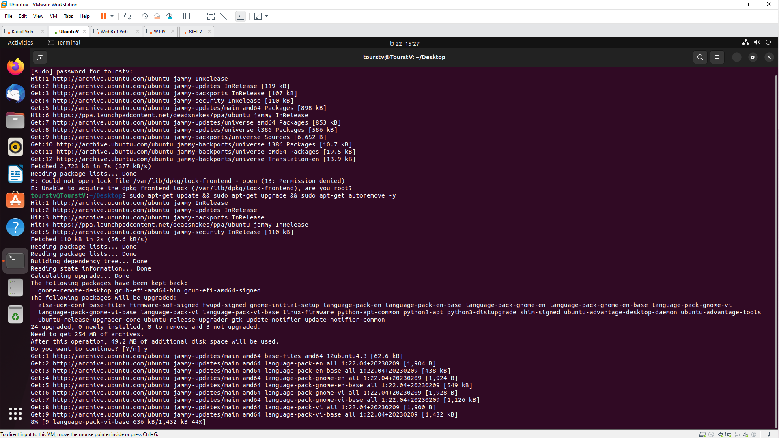

- sudo apt-get install python-software-properties 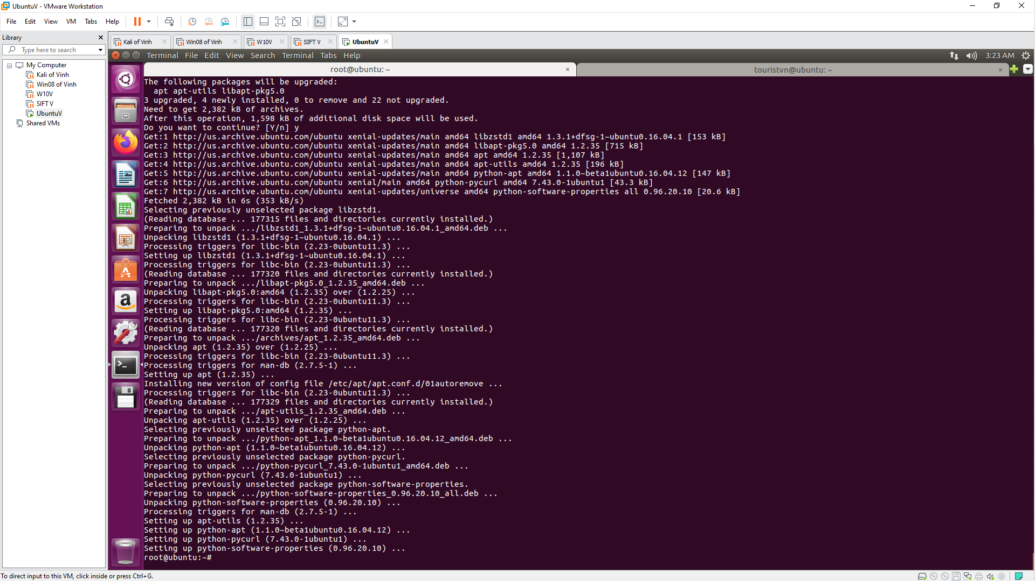

- sudo gedit /etc/network/interface
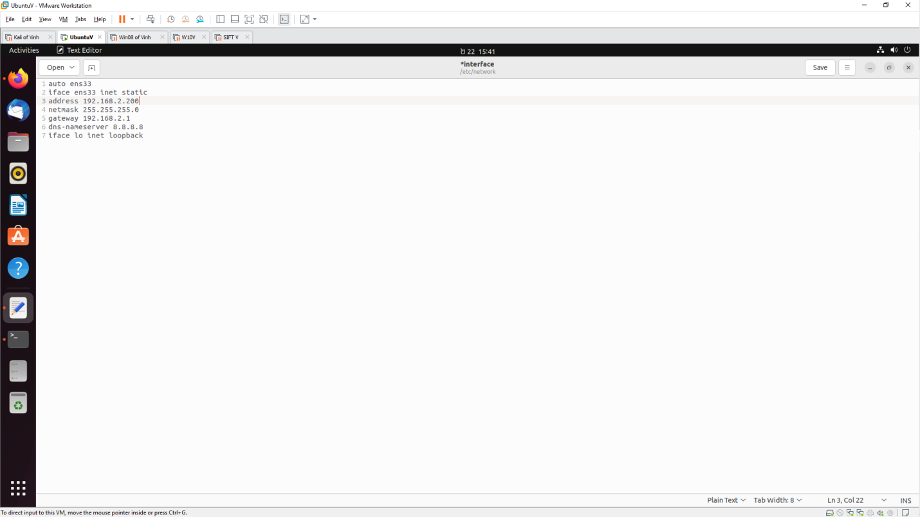

- sudo reboot now
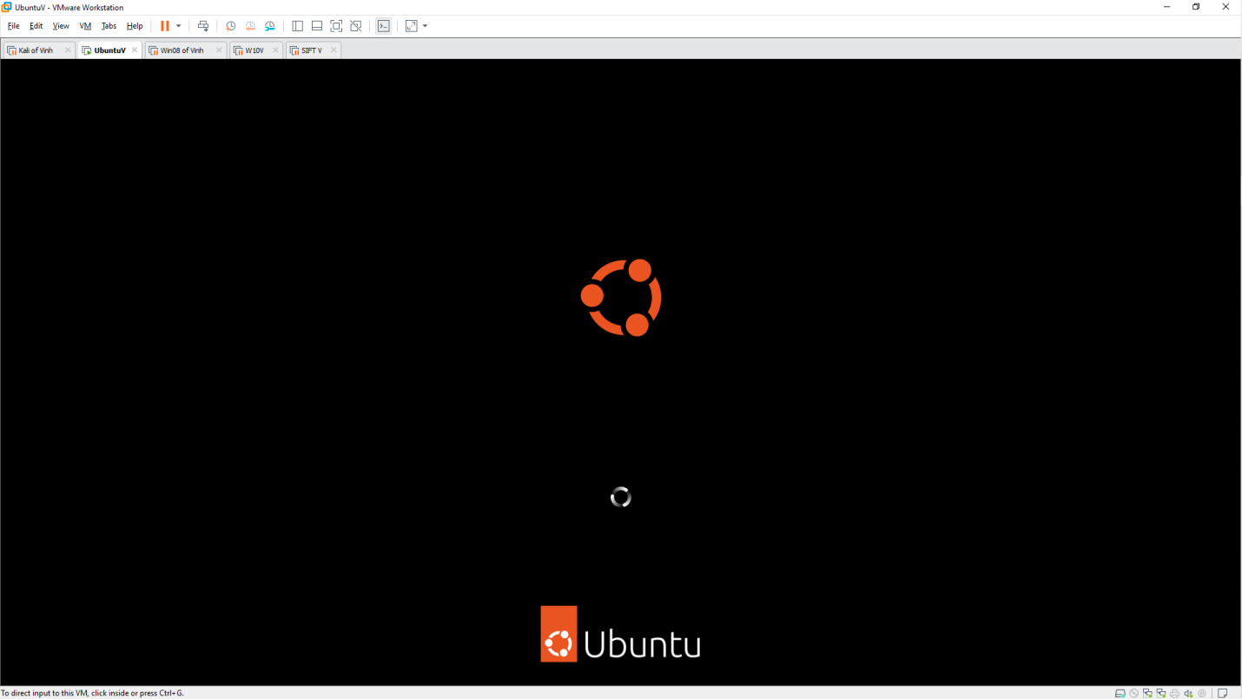

- git clone https://github.com/fogproject/fogproject.git fogproject-master
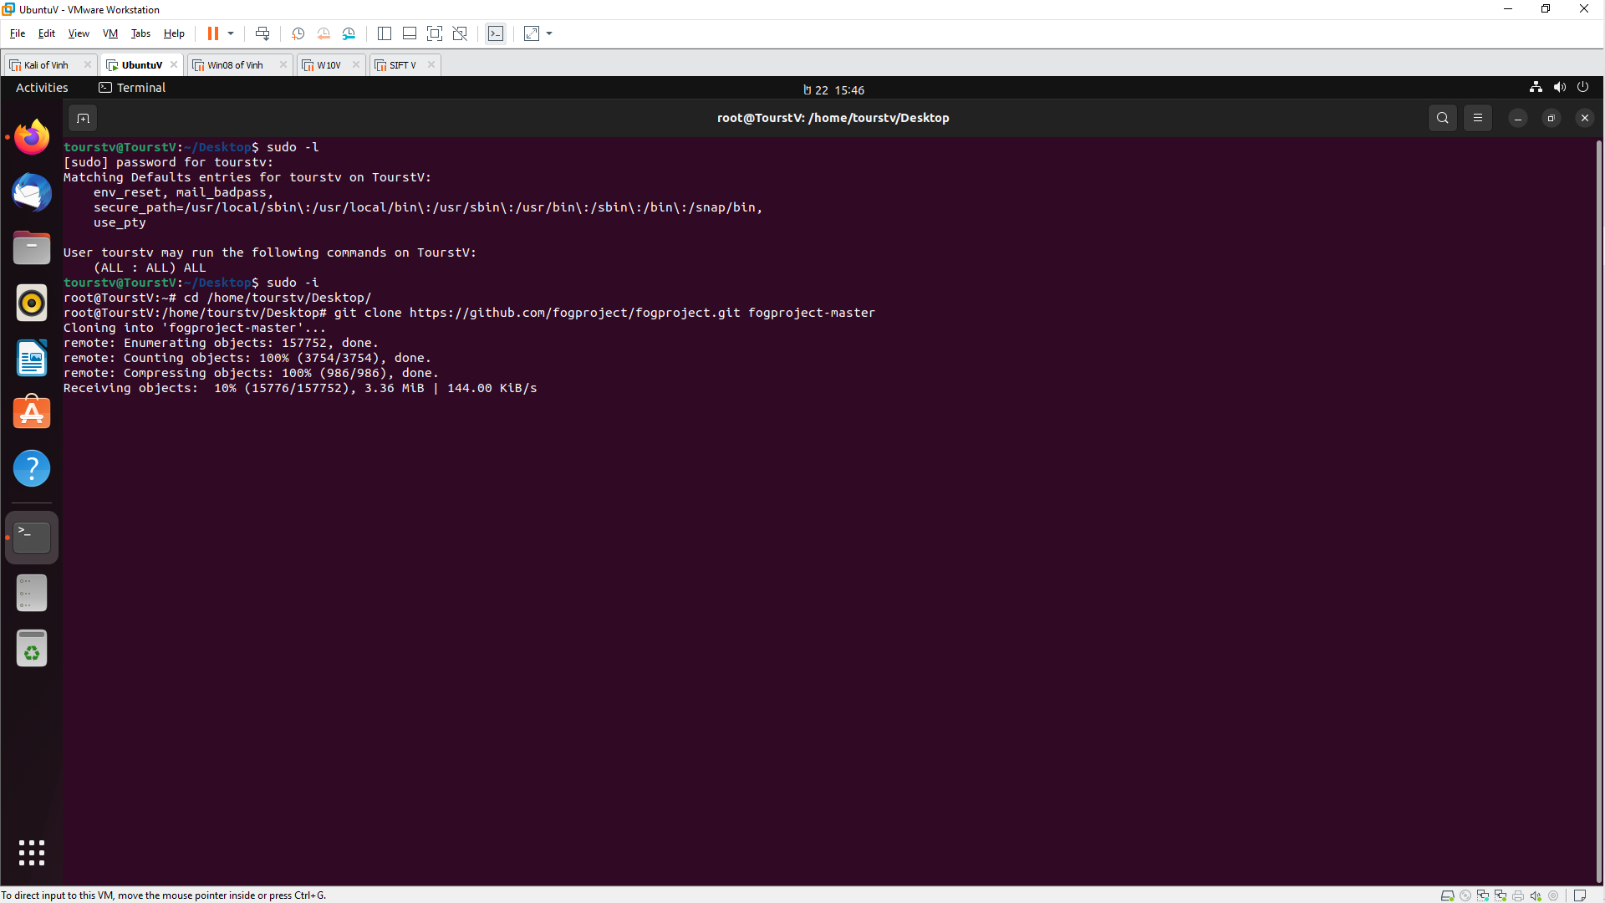

Because php7.1 does not exist in Ubuntu 16.04 so we need to change to php7.0 in /lib/ubuntu/config.sh
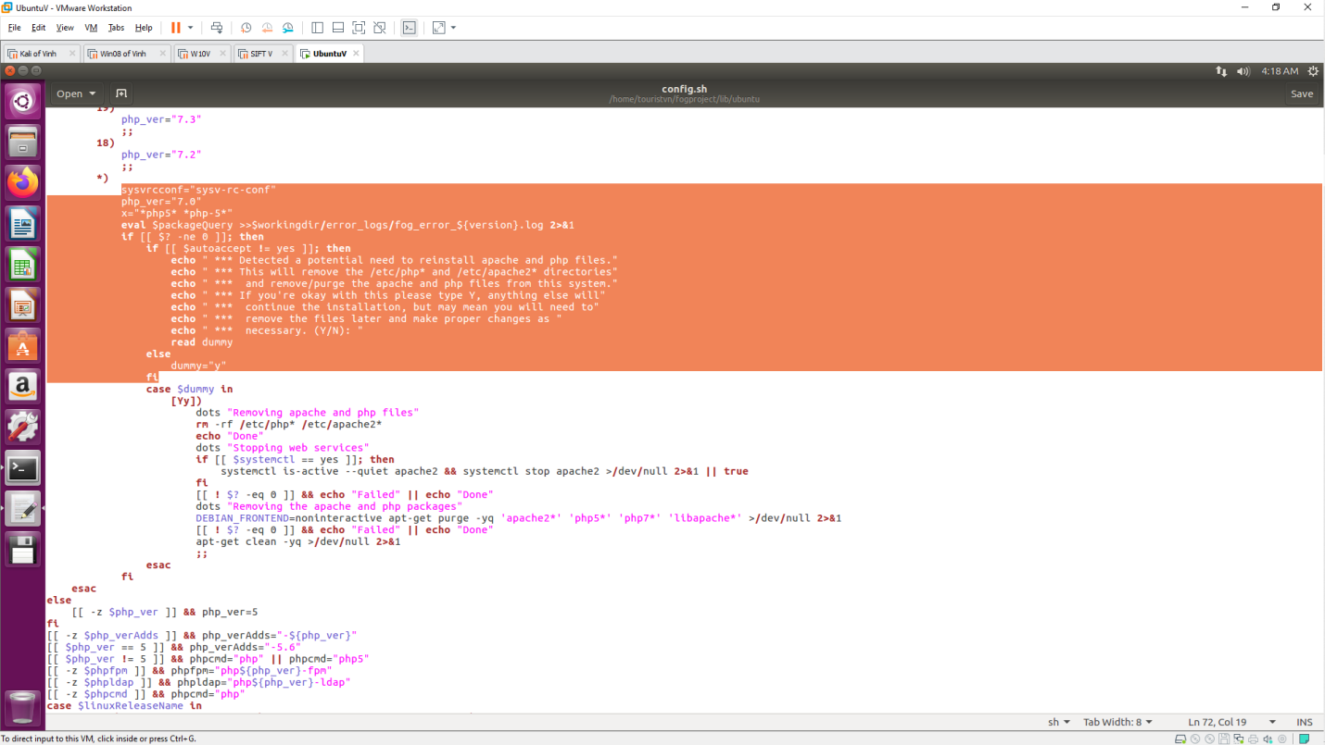

./installfog.sh
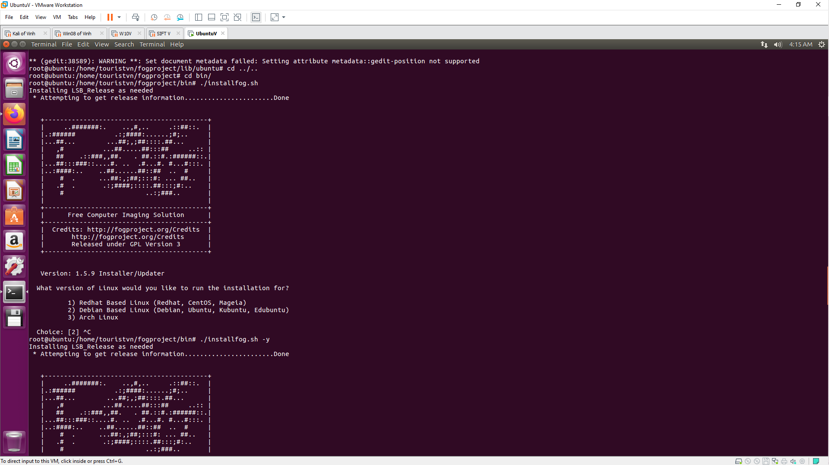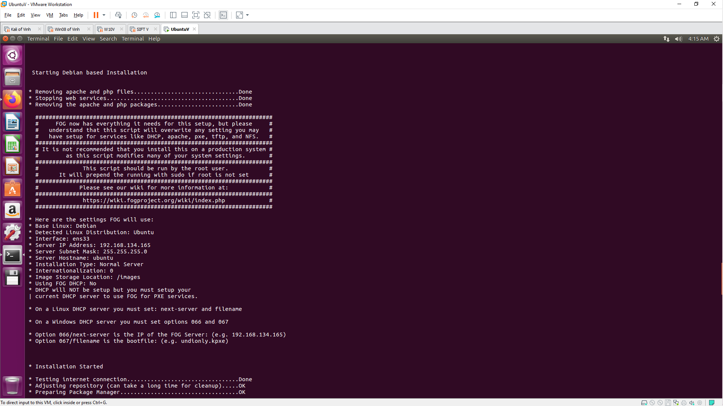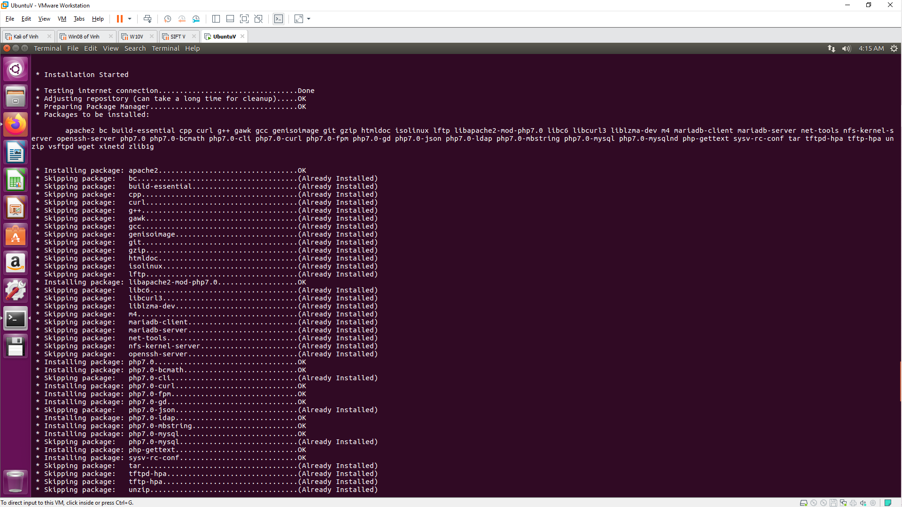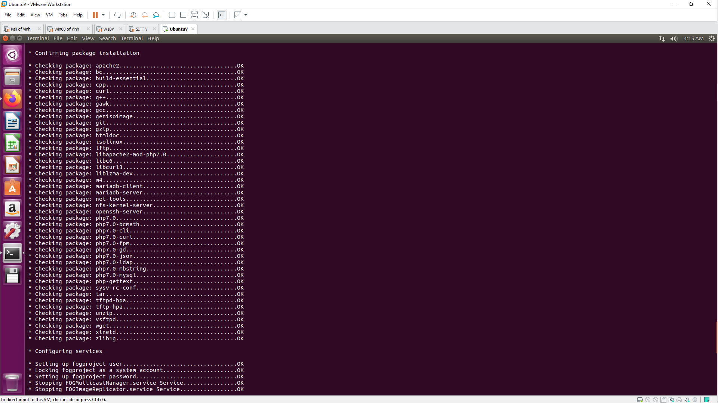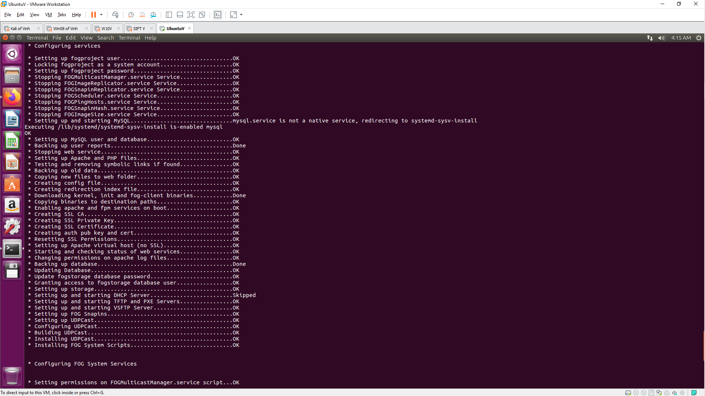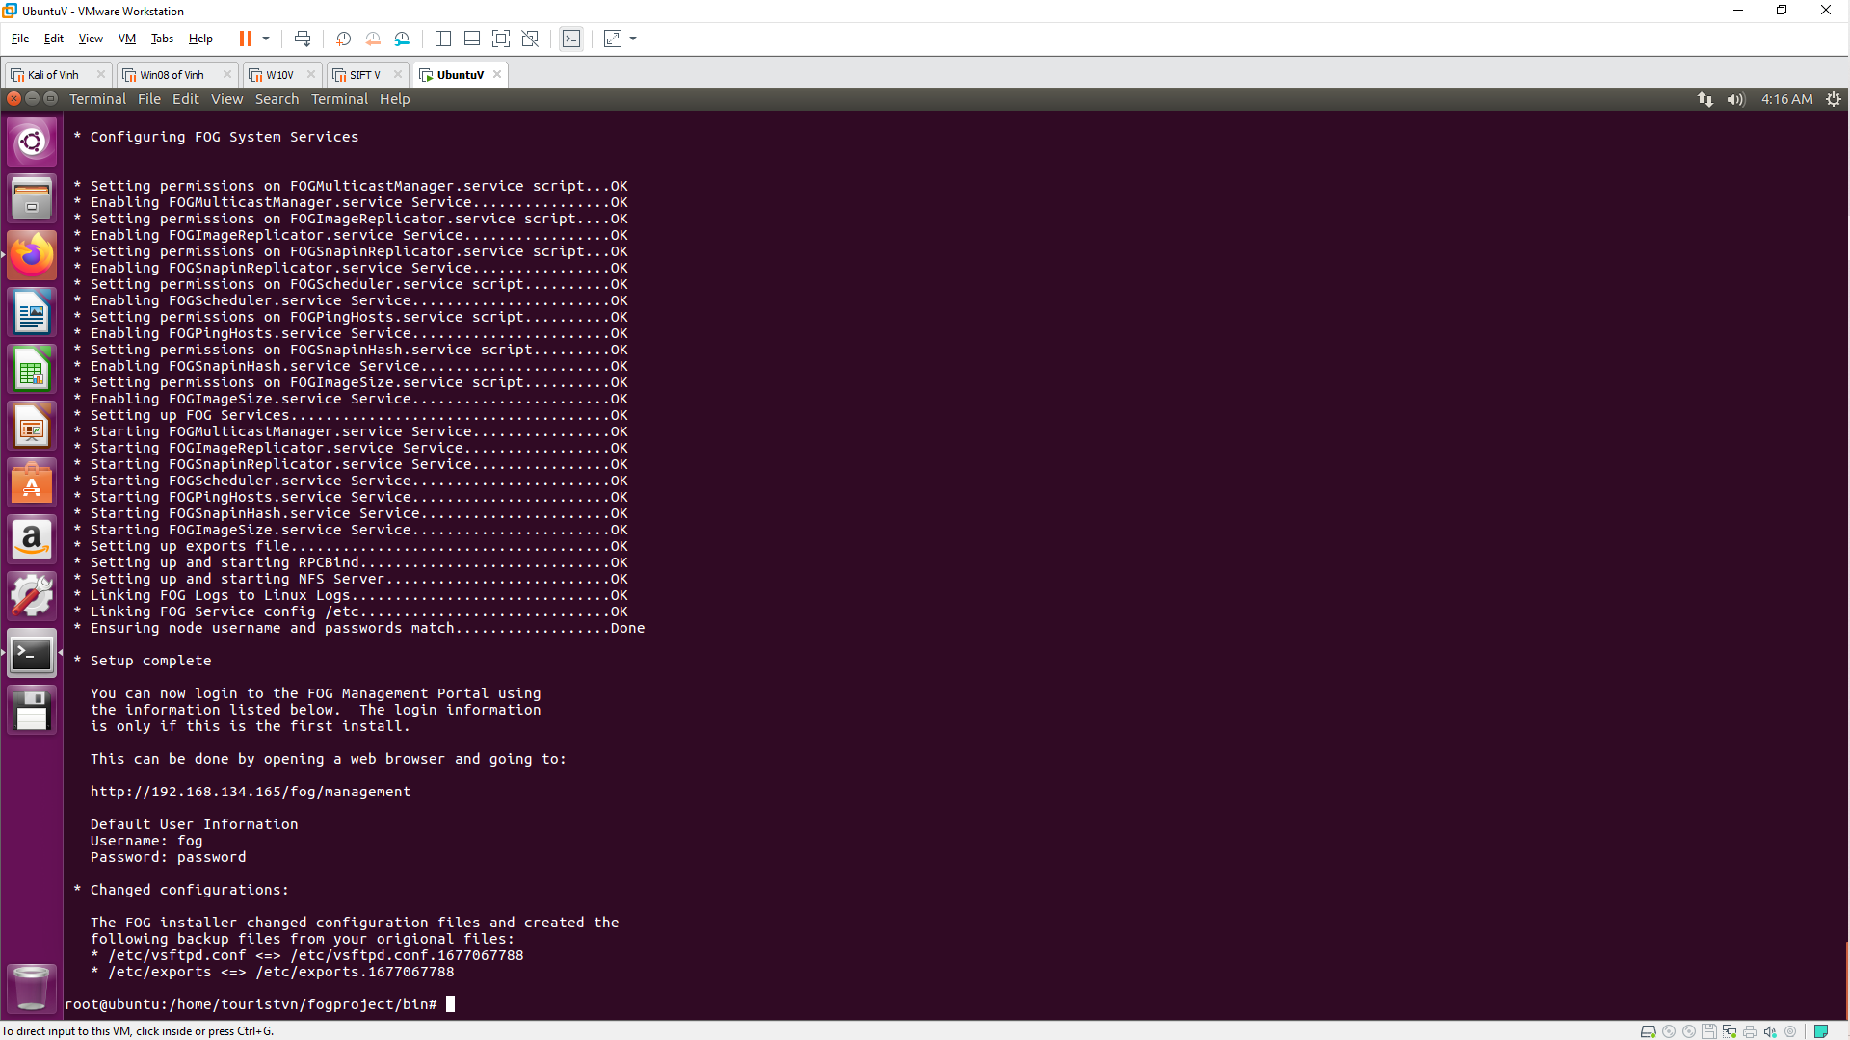

Login to http://192.168.134.165/fog/management
